CHAPTER 4: Systems — living connections
Worksheet 4.2

The digestive system
Student: Class:
The cells in your body need nutrients from food. The process of breaking down food into tiny particles takes place in your digestive system. The broken-down food is distributed to the cells of your body via the blood. The digestive system also removes indigestible food from your body.
1. (a) Draw in the parts that are missing from the diagram.
(b) Colour in each organ/part and label it with its correct name.
Organs of the digestive system
gall bladder | pancreas | stomach | oesophagus | liver | tongue
large intestine | small intestine | duodenum | rectum | anus
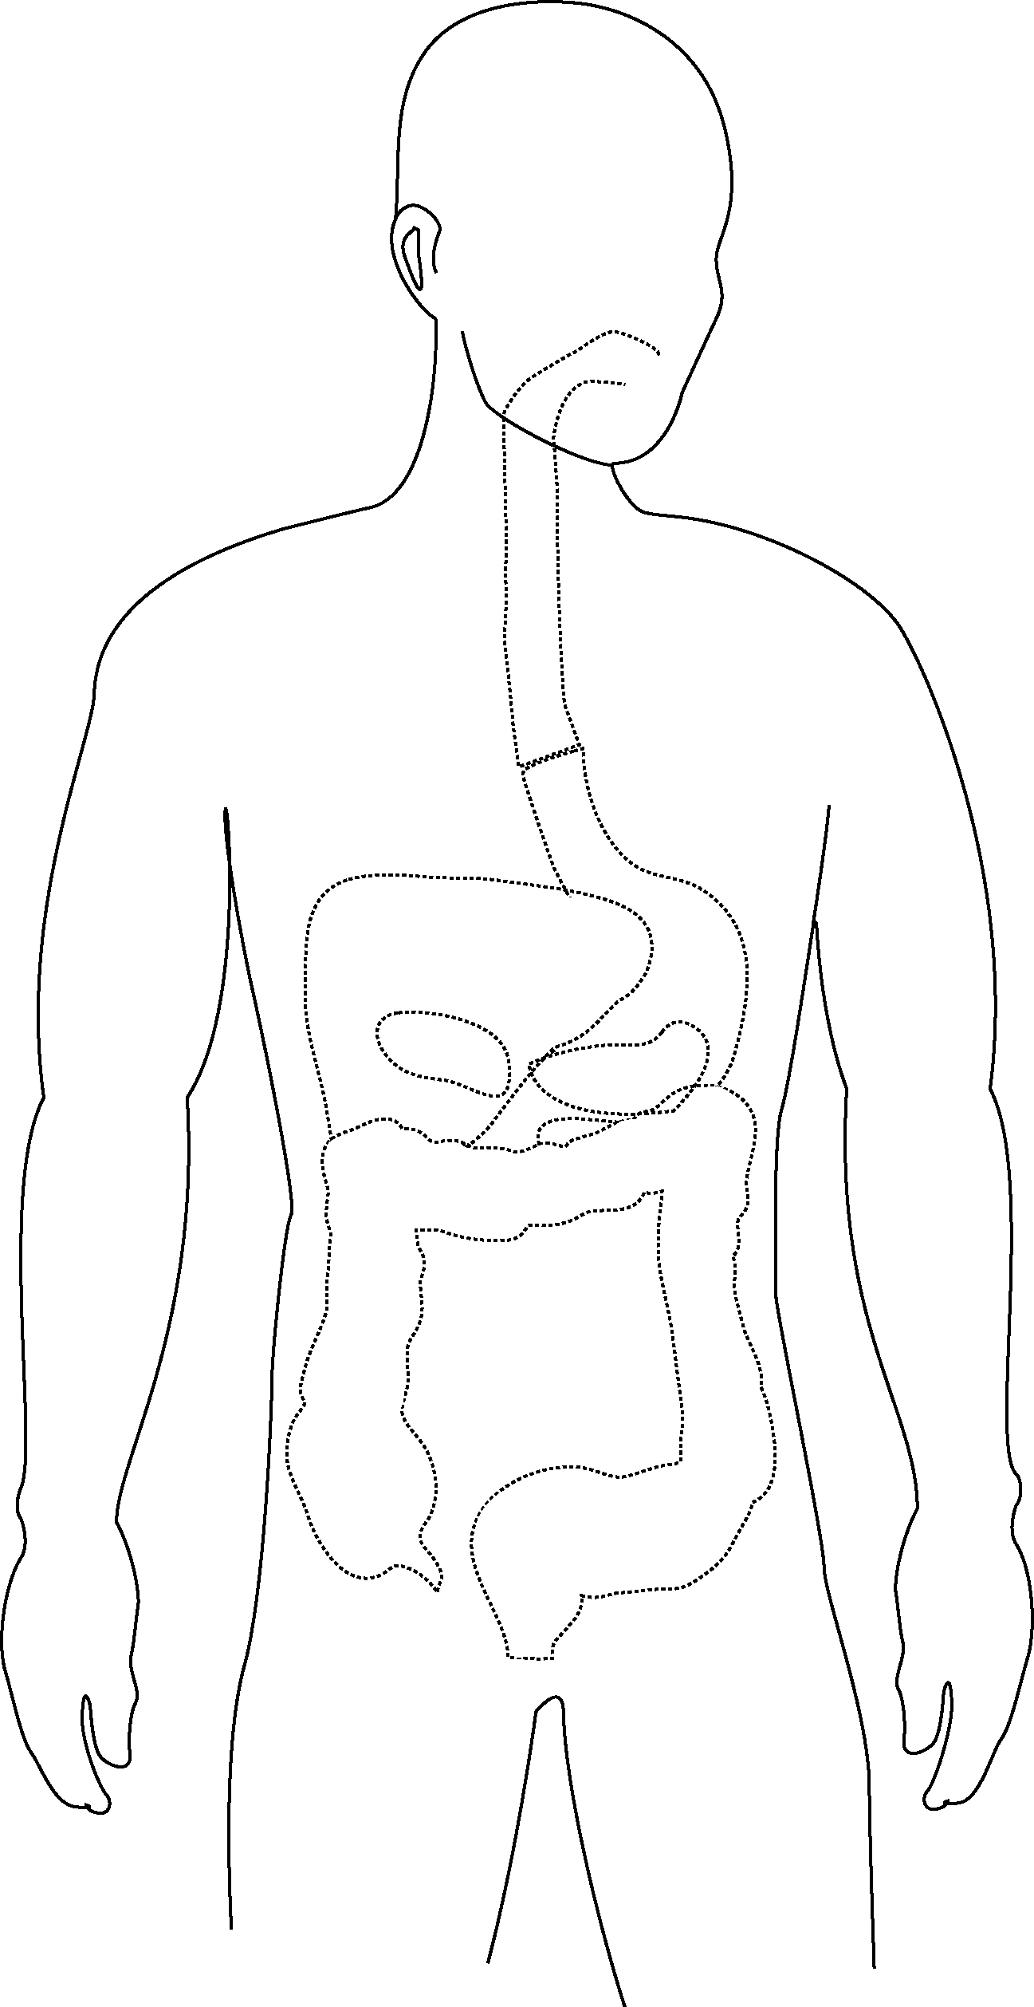

Time to digest
The pie chart below provides information about the time in minutes that food spends in each organ of the digestive system.
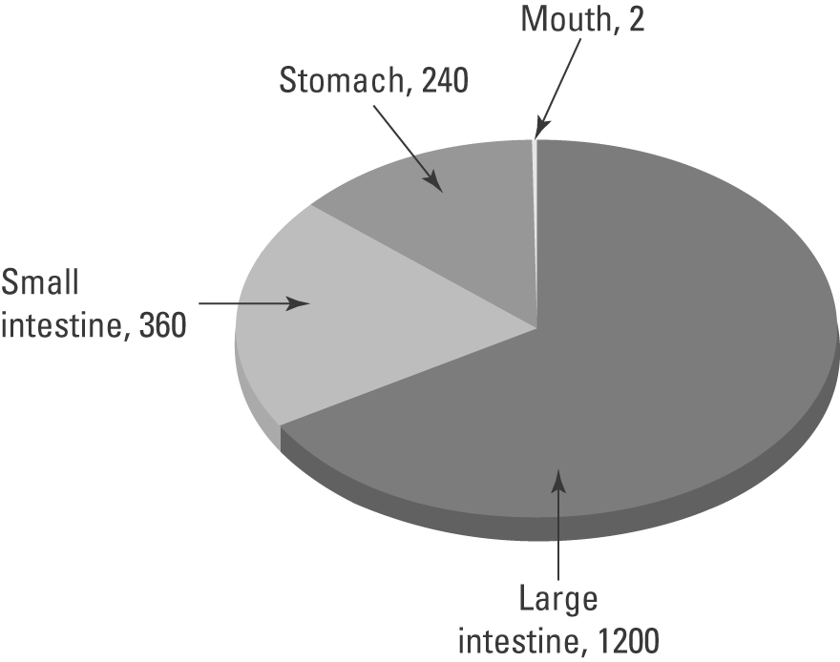
2. (a) Convert this information into a table.
(b) Calculate the number of hours that food spends in the large intestine.

